**PROJECT REPORT**

EXPLORATORY ANALYSIS OF RAINFALL DATA IN INDIA FOR AGRICULTURE

**­**

***submitted by***

***PNT2022TMID52711***

|  |  |  |
| --- | --- | --- |
| Aravind Gokul A | - | CITC1907003 |
| ­Pramoth Kanna P | - | CITC1907030 |
| Raghul Kannan B | - | CITC1907033 |
| Vedha B | - | CITC1907057 |

**TABLE OF CONTENTS**

1. **INTRODUCTION**

1.1PROJECT OVERVIEW 1

1.2 PURPOSE

1. **LITERATURE SURVEY 2**

2.1 EXISTING PROBLEM 2

2.2 REFERENCES 2

2.3 PROBLEM STATEMENT DEFINITION 5

1. **IDEATION AND PROPOSED SOLUTION 6**

3.1 EMPATHY MAP CANVAS 6

* 1. IDEATION & BRAINSTORMING 7
  2. PROPOSED SOLUTION 8

3.4 PROBLEM SOLUTION FIT 9

1. **REQUIREMENT ANALYSIS** **10**

4.1 FUNCTIONAL REQUIREMENTS 10

* 1. NON FUNCTIONAL REQUIREMENTS 11

1. **PROJECT DESIGN 12**

5.1 DATA FLOW DIAGRAM 12

* 1. SOLUTION & TECHNICAL ARCHITECTURE 13
  2. USER STORIES 15

**6 PROJECT PLANNING AND SCHEDULING 16**

6.1 SPRINT PLANNING AND ESTIMATION 16

* 1. SPRINT DELIVERY SCHEDULE 17

**7 CODING & SOLUTIONING 18**

**8 TESTING 20**

8.1 TEST CASES 20

* 1. USER ACCEPTANCE TESTING 22

8.2.1 DEFECT ANALYSIS 22

8.2.2TEST CASE ANALYSIS 22

1. **RESULTS 23**

9.1 PERFORMANCE METRICS 23

1. **ADVANTAGES & DISADVANTAGES 25**

ADVANTAGES 25

DISADVANTAGES 25

**11 CONCLUSION 26**

**12 FUTURE SCOPE 27**

**APPENDIX 28**

SOURCE CODE 28

GITHUB 37

PROJECT DEMO 37

# CHAPTER 1

## INTRODUCTION

### PROJECT OVERVIEW

Machine learning and deep learning play an important role in computer technology and artiﬁcial intelligence.

With the use of deep learning and machine learning, human effort can be reduced in recognizing, learning, predictions and in many more areas. Agriculture is the backbone of the Indian economy. For agriculture, the most important thing is water source, i.e. rainfall. The prediction of the amount of rainfall gives alertness to farmers by knowing early they can protect their crops from rain. So, it is important to predict the rainfall accurately as much as possible. Exploration and analysis of data on rainfall over various regions of India and especially the regions where agricultural works have been done persistently in a wide range.

### PURPOSE

Analysis of rainfall data is important as it facilitates policy decisions regarding the cropping pattern, sowing date, construction of roads and providing drinking water to urban and rural areas.

# CHAPTER 2

## LITERATURE SURVEY

### EXISTING PROBLEM

India is an agricultural country and secondary agricultural based market will be steady with a good monsoon. The economic growth of each year depends on the amount of duration of monsoon rain, bad monsoon can lead to destruction of some crops, which may result in scarcity of some agricultural products which in turn can cause food inflation, insecurity and public unrest. Therefore, the goal of this project is to understand the behavior of rainfall in India over the years, by months and different subdivisions.

### REFERENCES

# 

# Title: A Prediction of Yibin City Based on GRU and XGBoost

**Author:** [Shamima Akter](https://ieeexplore.ieee.org/author/37085539441); [Ahsan Habib](https://ieeexplore.ieee.org/author/37088601009); [Md. Ashiqul Islam](https://ieeexplore.ieee.org/author/37086532897); [Md. Sagar Hossen](https://ieeexplore.ieee.org/author/37088522799)

In this paper, GRU and XGBoost algorithms are used to predict the rainfall in Yibin City, Sichuan Province, and the different prediction results of the two methods are compared. Experiments have found that the mean absolute error (MAE) of GRU and XGBoost models are 0.088 and 0.013 respectively; The mean square error (MSE) is 0.016 and 0.0003 respectively; The mean average absolute percentage error (MAPE) was 58.22 and 14.85 respectively. In the two prediction models, the prediction error of the XGBoost model is smaller.

**Title: Machine Learning based Rainfall Prediction**

**Author:** [Linta Antony](https://ieeexplore.ieee.org/author/37088967777), [Sami Azam](https://ieeexplore.ieee.org/author/38235919100), [Eva Ignatious](https://ieeexplore.ieee.org/author/37088703022)

This paper proposes a rainfall prediction model using Multiple Linear Regression (MLR) for Indian dataset. The input data has multiple meteorological parameters and to predict the rainfall more precisely. The Mean Square Error (MSE), accuracy, and correlation are the parameters used to validate the proposed model. From the results of this paper, the proposed machine learning model provides better results than the other algorithms in the literature.

**Title: Analyzing trend and forecasting of rainfall changes in India using non parametric and machine learning approaches.**

**Author:** [Chaity Mondol](https://sciprofiles.com/profile/author/akllQ2VKUzVMbnJvMFVjTDV6a3JwbnJTc0xSdEUxNnVWWXltczNLWEtNRT0=),[F. M. Javed Mehedi Shamrat](https://sciprofiles.com/profile/1757506)[Md. Robiul Hasan](https://sciprofiles.com/profile/2408243).

This study analyzes and forecasts the long-term Spatio-temporal changes in rainfall using the data from 1901 to 2015 across India at meteorological divisional level. The Pettitt test was used to detect the changing point in the time frame. Mann-Kendall (MK) test and Sen’s Innovative trend analysis were performed to analyze the rainfall trend. Artificial Neural Network-Multilayer Perceptron (ANN-MLP) was employed to forecast the upcoming 15 years rainfall across India. Result - The increasing rainfall trend was observed during the period 1901–1950, while a significant decline in rainfall was detected after 1951.

#### Title: A Time-series based Prediction Analysis of Rainfall Detection.

**Author:** [Guozhen Chen](https://ieeexplore.ieee.org/author/37088415552),[Chenguang Ding](https://ieeexplore.ieee.org/author/37088414755).

This study analyzes and forecasts the long-term Spatio-temporal changes in rainfall using the data from 1901 to 2015 across India at meteorological divisional level. The Pettitt test was used to detect the changing point in the time frame. Mann-Kendall (MK) test and Sen’s Innovative trend analysis were performed to analyze the rainfall trend. Artificial Neural Network-Multilayer Perceptron (ANN-MLP) was employed to forecast the upcoming 15 years rainfall across India. Result - The increasing rainfall trend was observed during the period 1901–1950, while a significant decline in rainfall was detected after 1951.

# Title: Machine Learning Techniques to Predict Daily Rainfall Amount

**Author:** [R Devika](https://ieeexplore.ieee.org/author/37086478639); [Sai Vaishnavi Avilala](https://ieeexplore.ieee.org/author/37086959841); [V. Subramaniyaswamy](https://ieeexplore.ieee.org/author/37086398299)

Main objective of the project was to identify the relevant atmospheric features that cause rainfall and predict the intensity of daily rainfall using machine learning techniques. The Pearson correlation technique was used to select relevant environmental variables which were used as an input for the machine learning model. The dataset was collected from the local meteorological office at Bahir Dar City, Ethiopia. Three machine learning models were used - Multivariate Linear Regression, Random Forest, and Extreme Gradient Boost.

### PROBLEM STATEMENT DEFINITION

# India is an agricultural country and secondary agricultural based market will be steady with a good monsoon.

# The economic growth of each year depends on the amount of duration of monsoon rain, bad monsoon can lead to destruction of some crops, which may result in scarcity of some agricultural products which in turn can cause food inflation, insecurity and public unrest.

# Therefore, the goal of this project is to understand the behavior of rainfall in India over the years, by months and different subdivisions.

# CHAPTER 3

## IDEATION AND PROPOSED SOLUTION

### EMPATHY MAP CANVAS

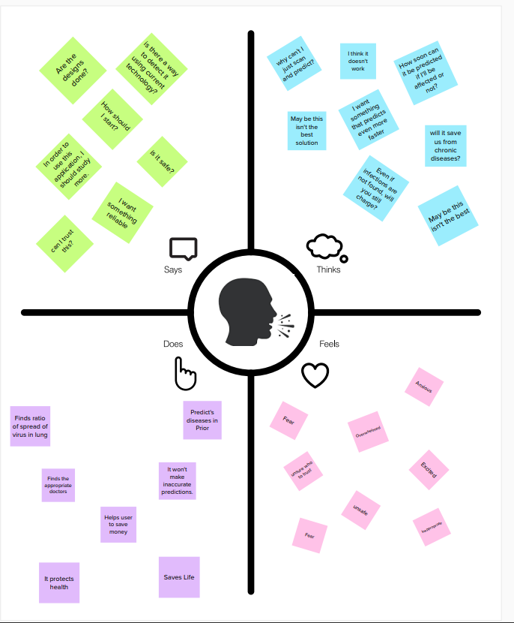

### IDEATION & BRAINSTORMING

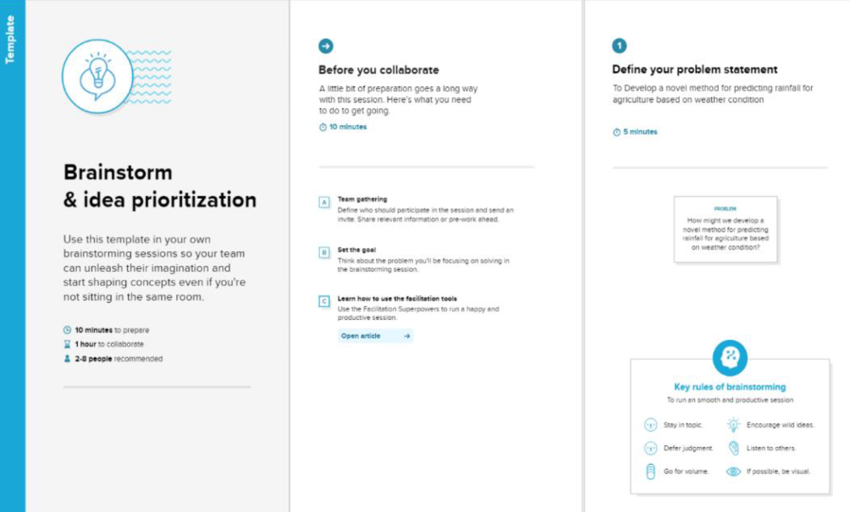

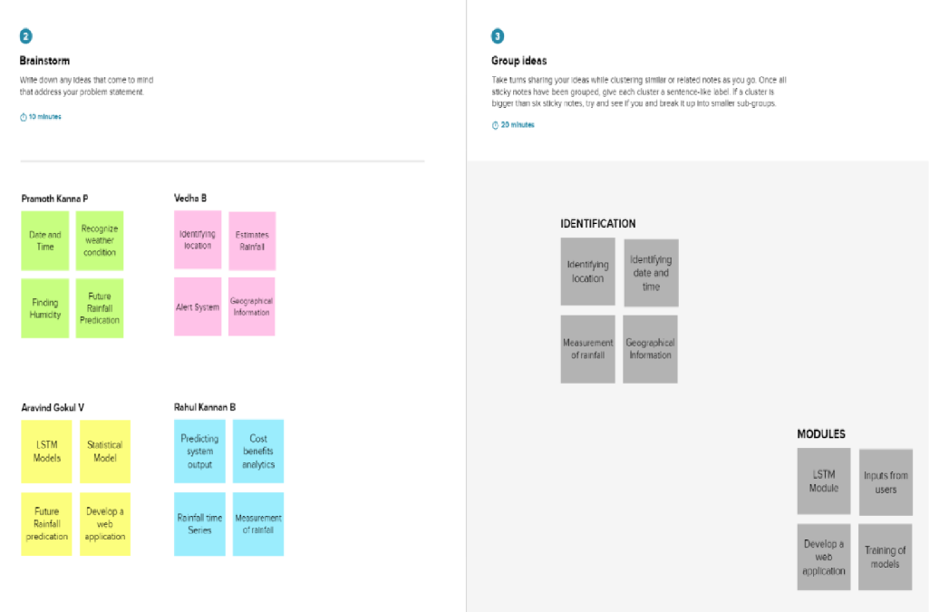

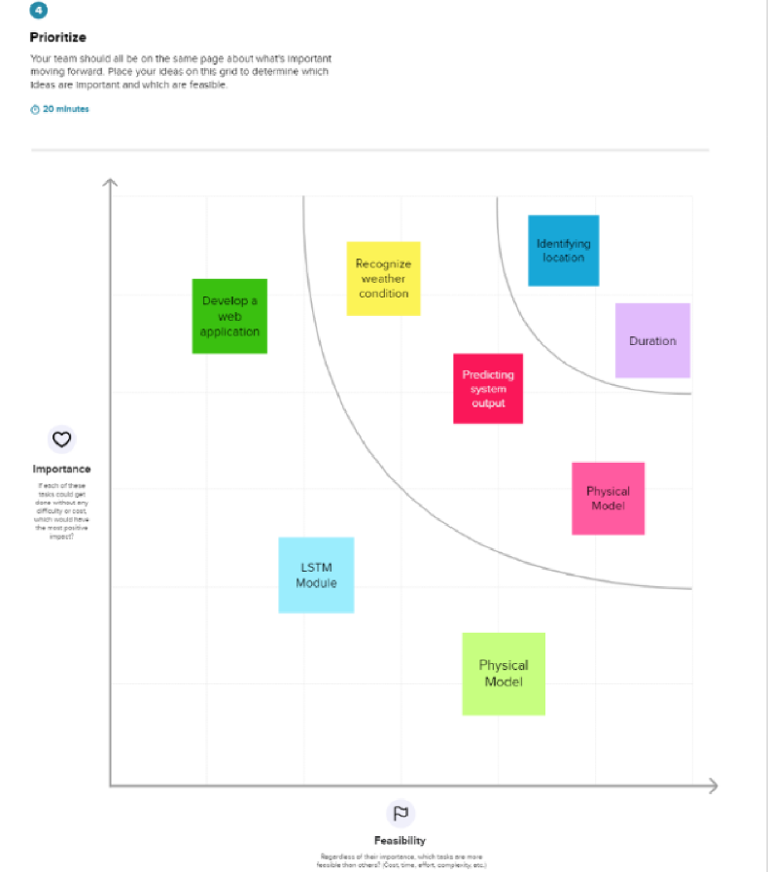

### PROPOSED SOLUTION

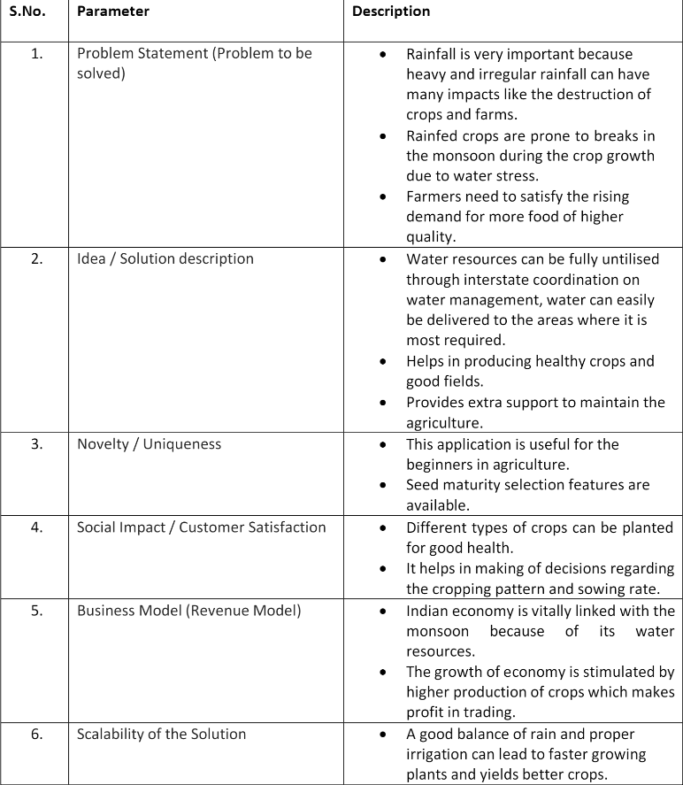

### PROBLEM SOLUTION FIT

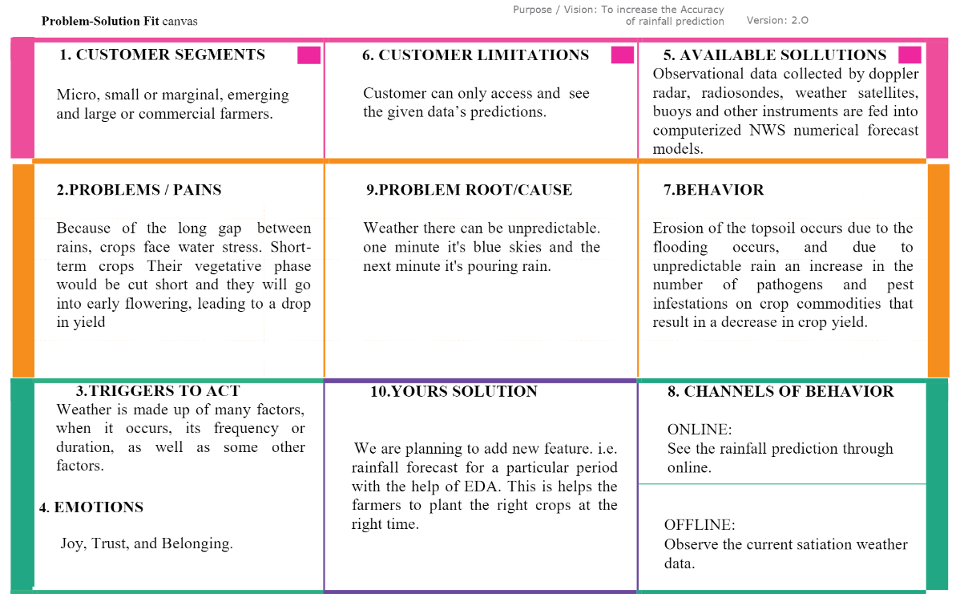

# CHAPTER 4

## REQUIREMENT ANALYSIS

### FUNCTIONAL REQUIREMENTS

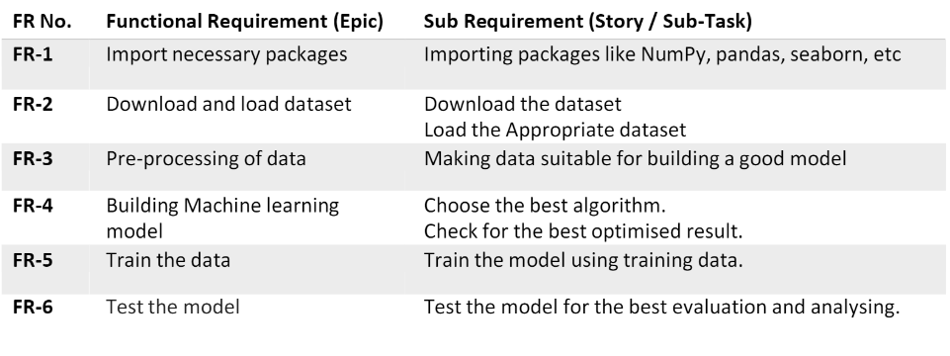

### NON FUNCTIONAL REQUIREMENTS

### 

# CHAPTER 5

## PROJECT DESIGN

### DATA FLOW DIAGRAM

### 

### SOLUTION & TECHNICAL ARCHITECTURE

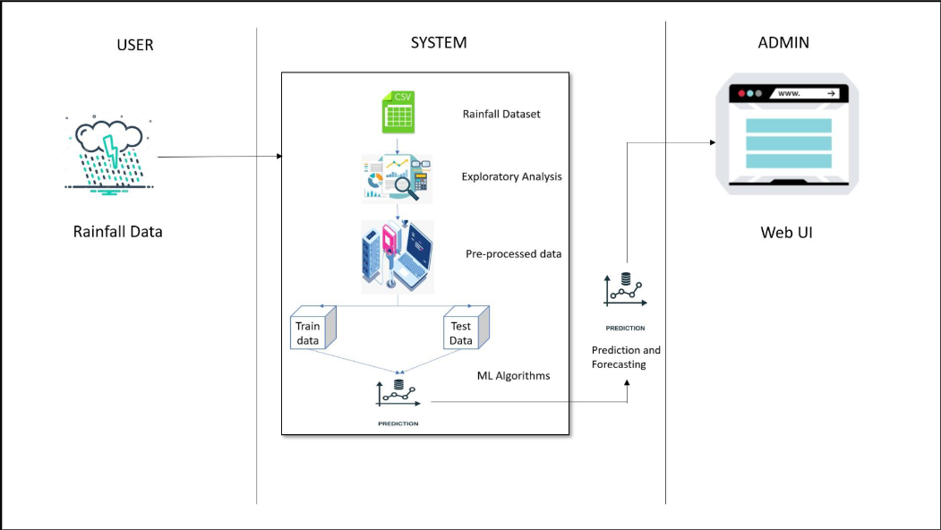

### USER STORIES

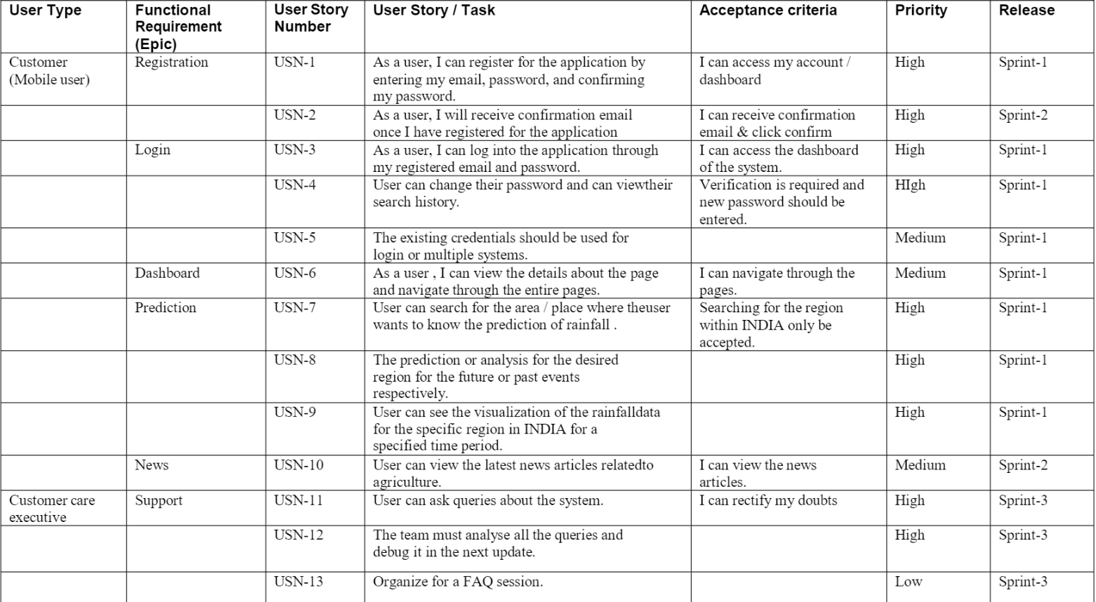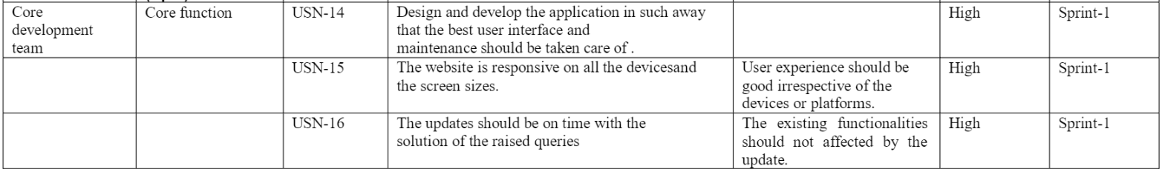

# CHAPTER 6

## PROJECT PLANNING AND SCHEDULING

### SPRINT PLANNING AND ESTIMATION

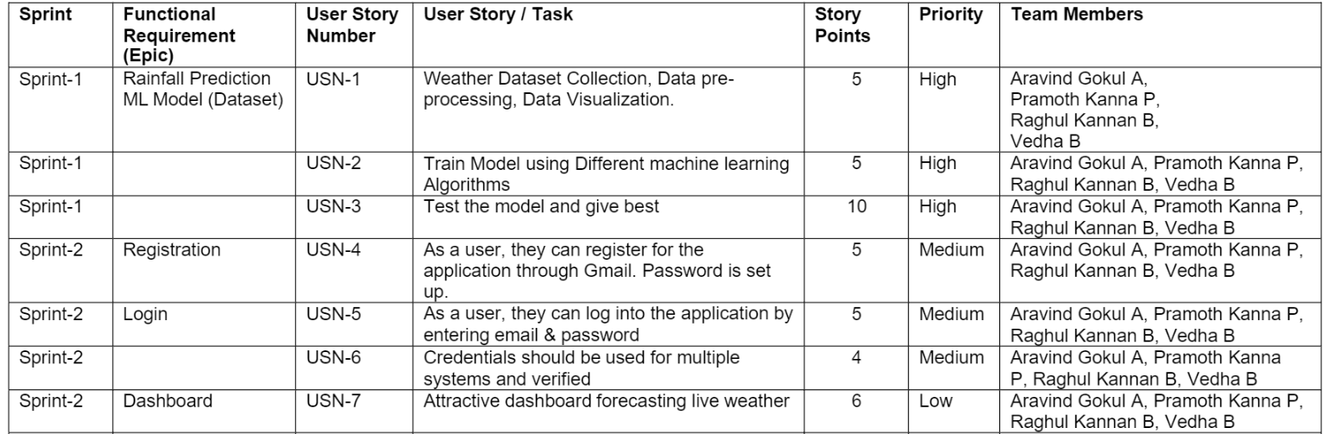

 

### 6.2 SPRINT DELIVERY SCHEDULE

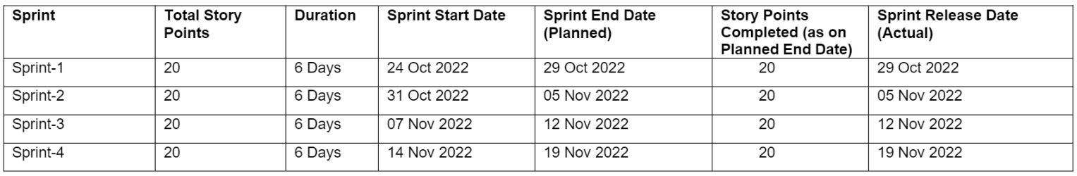

# CHAPTER 7

**CODING & SOLUTIONING**

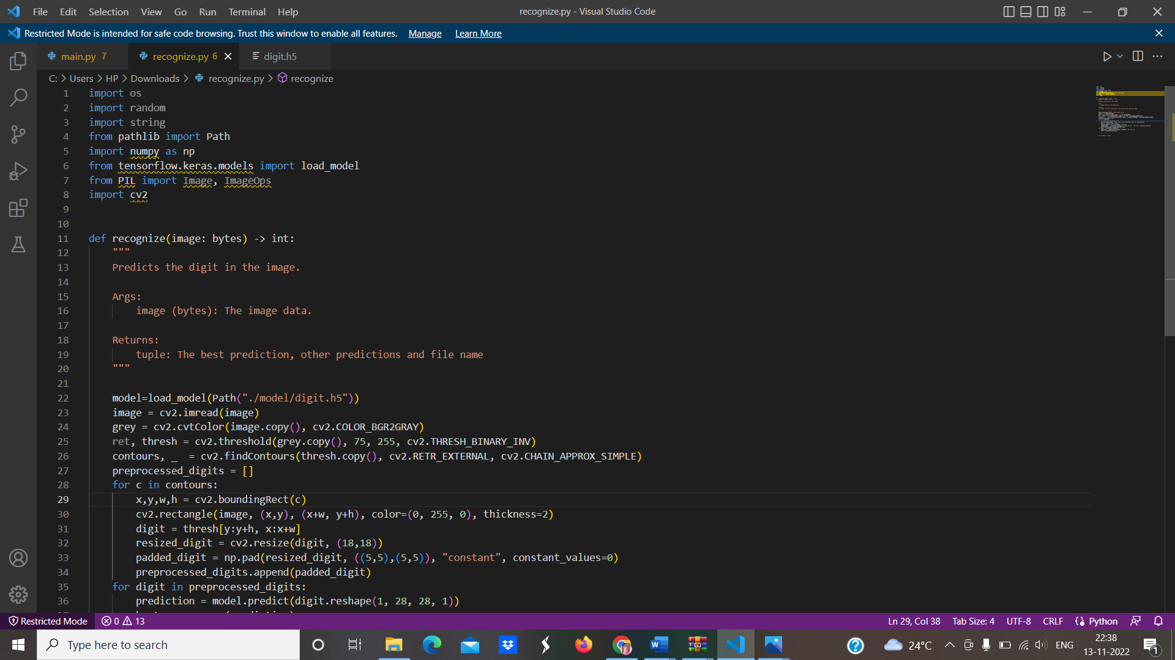

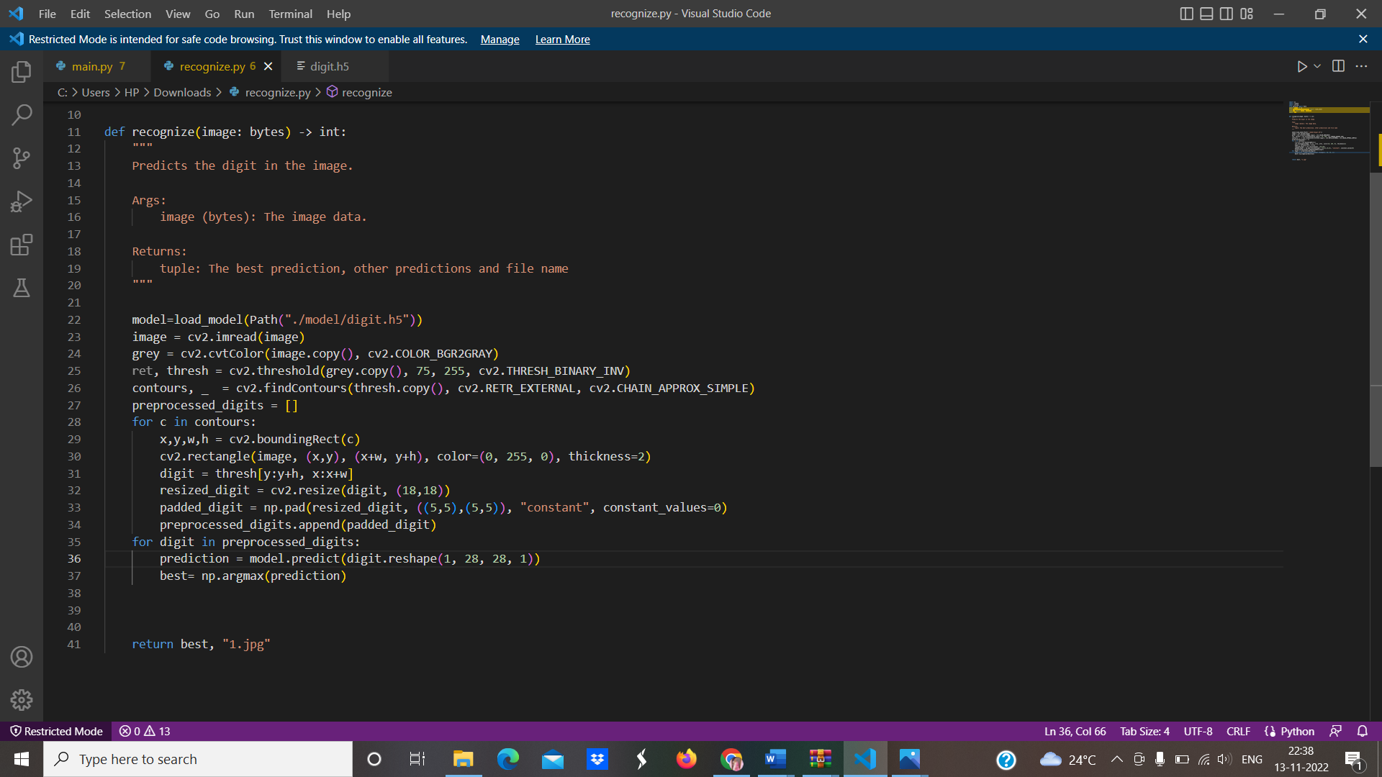

# CHAPTER 8

## TESTING

### TEST CASES

|  |  |  |  |  |  |  |
| --- | --- | --- | --- | --- | --- | --- |
| **Test case ID** | **Feature Type** | **Component** | **Test Scenario** | **Expected Result** | **Actual Result** | **Status** |
| HP_TC_001 | UI | Home Page | Verify UI elements in the Home Page | The Home page must be displayed properly | Working as expected | PASS |
| HP_TC_002 | UI | Home Page | Check if the UI elements are displayed properly in different screen sizes | The Home page must be displayed properly in all sizes | The UI is not displayed properly in screen size 2560 x 1801  and 768 x 630 | FAIL |
| HP_TC_003 | Functional | Home Page | Check if the page redirects to the result page once the input is given | The page should redirect to the results page | Working as expected | PASS |

|  |  |  |  |  |  |  |
| --- | --- | --- | --- | --- | --- | --- |
| BE_TC_001 | Functional | Backend | Check if all the routes are working properly | All the routes should properly work | Working as expected | PASS |
| M_TC_001 | Functional | Model | Check if the model can handle various datas | The model should process the data and predict the results | Working as expected | PASS |
| M_TC_002 | Functional | Model | Check if the model predicts the crops | The model should predict the crops | Working as expected | PASS |
| M_TC_003 | Functional | Model | Check if the model can handle complex input datas | The model should predict the number in the complex datas | The model fails to identify the crops since the model is not built to handle such complex datas | FAIL |
| RP_TC_001 | UI | Result Page | Verify UI elements in the Result Page | The Result page must be displayed properly | Working as expected | PASS |
| RP_TC_002 | UI | Result Page | Check if the result is displayed properly | The result should be displayed properly | Working as expected | PASS |
| RP_TC_003 | UI | Result Page | Check if the other predictions are displayed properly | The other predictions should be displayed properly | Working as expected | PASS |

### USER ACCEPTANCE TESTING

### DEFECT ANALYSIS

|  |  |  |  |  |  |
| --- | --- | --- | --- | --- | --- |
| Resolution | Severity 1 | Severity 2 | Severity 3 | Severity 4 | Total |
| By Design | 1 | 0 | 1 | 0 | 2 |
| Duplicate | 0 | 0 | 0 | 0 | 0 |
| External | 0 | 0 | 1 | 0 | 1 |
| Fixed | 1 | 1 | 0 | 0 | 2 |
| Not Reproduced | 0 | 0 | 0 | 1 | 1 |
| Skipped | 0 | 0 | 0 | 1 | 1 |
| Won’t Fix | 0 | 0 | 0 | 0 | 0 |
| Total | 2 | 1 | 2 | 2 | 7 |

### TEST CASE ANALYSIS

|  |  |  |  |  |
| --- | --- | --- | --- | --- |
| Section | Total Cases | Not Tested | Fail | Pass |
| Client Application | 5 | 0 | 1 | 4 |
| Security | 2 | 0 | 1 | 1 |
| Performance | 2 | 0 | 1 | 1 |
| Exception Reporting | 2 | 0 | 0 | 2 |

# CHAPTER 9

## RESULTS

### PERFORMANCE METRICS

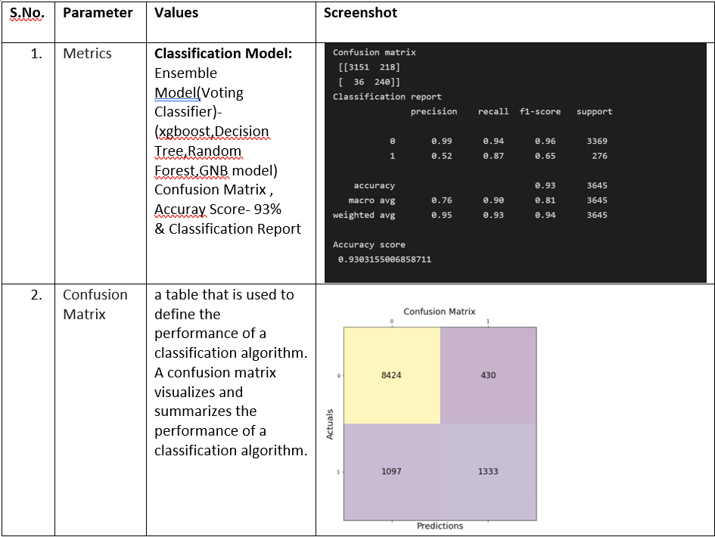

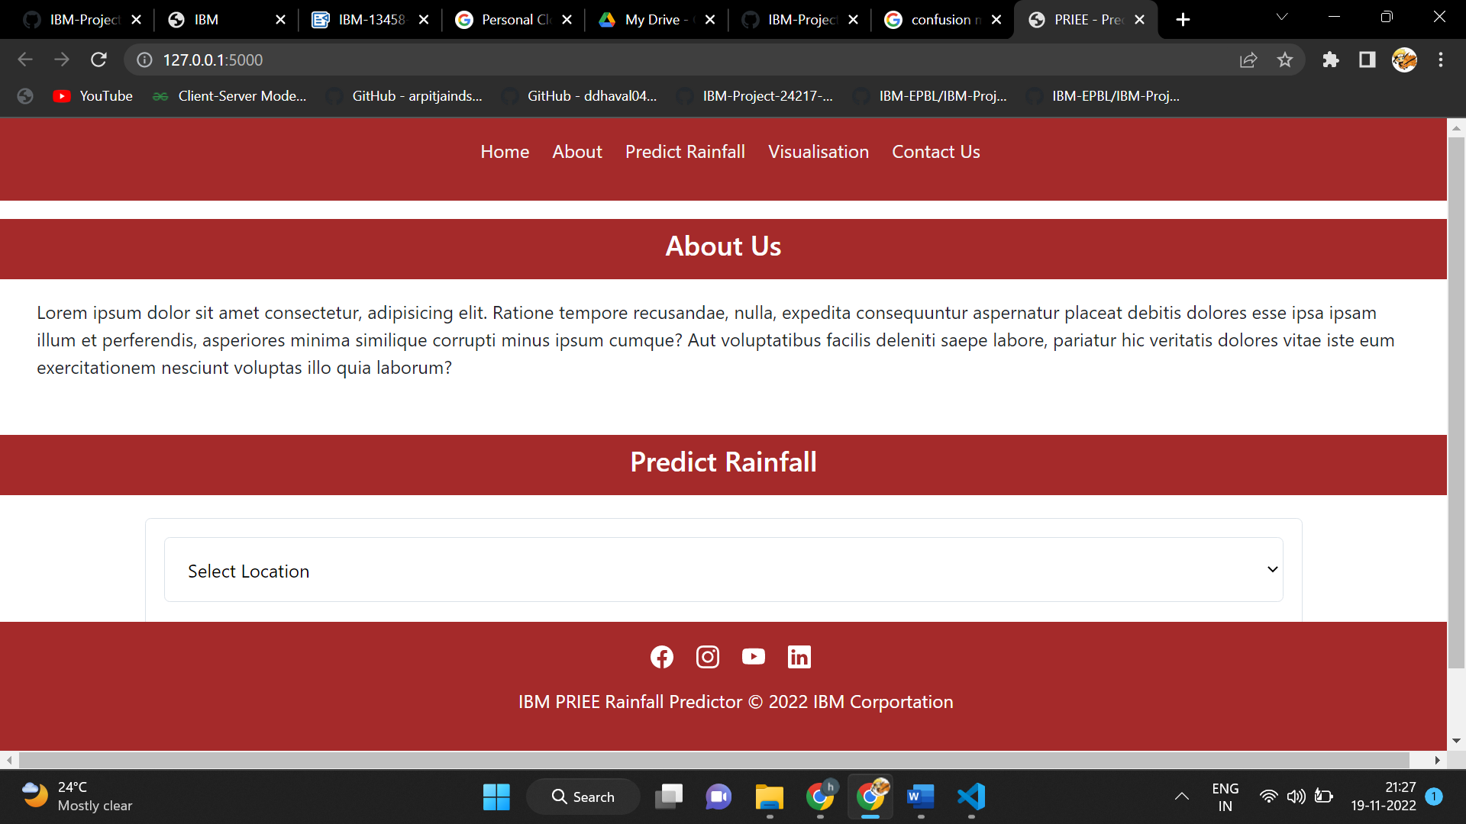

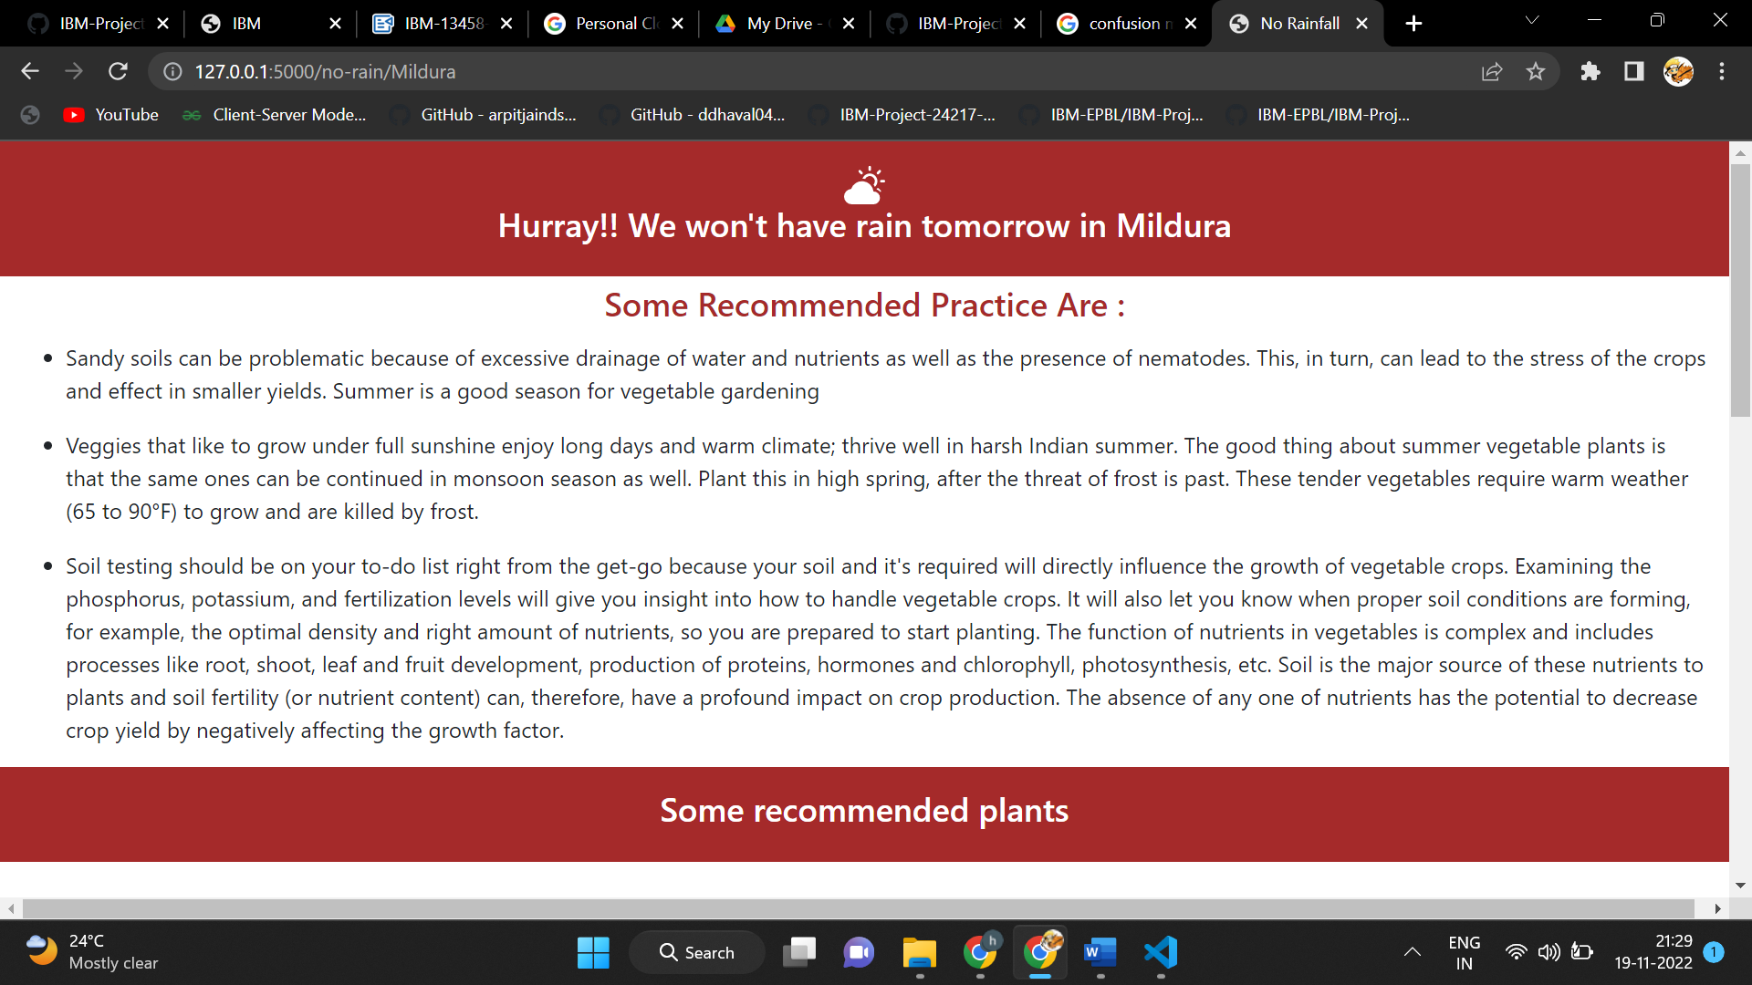

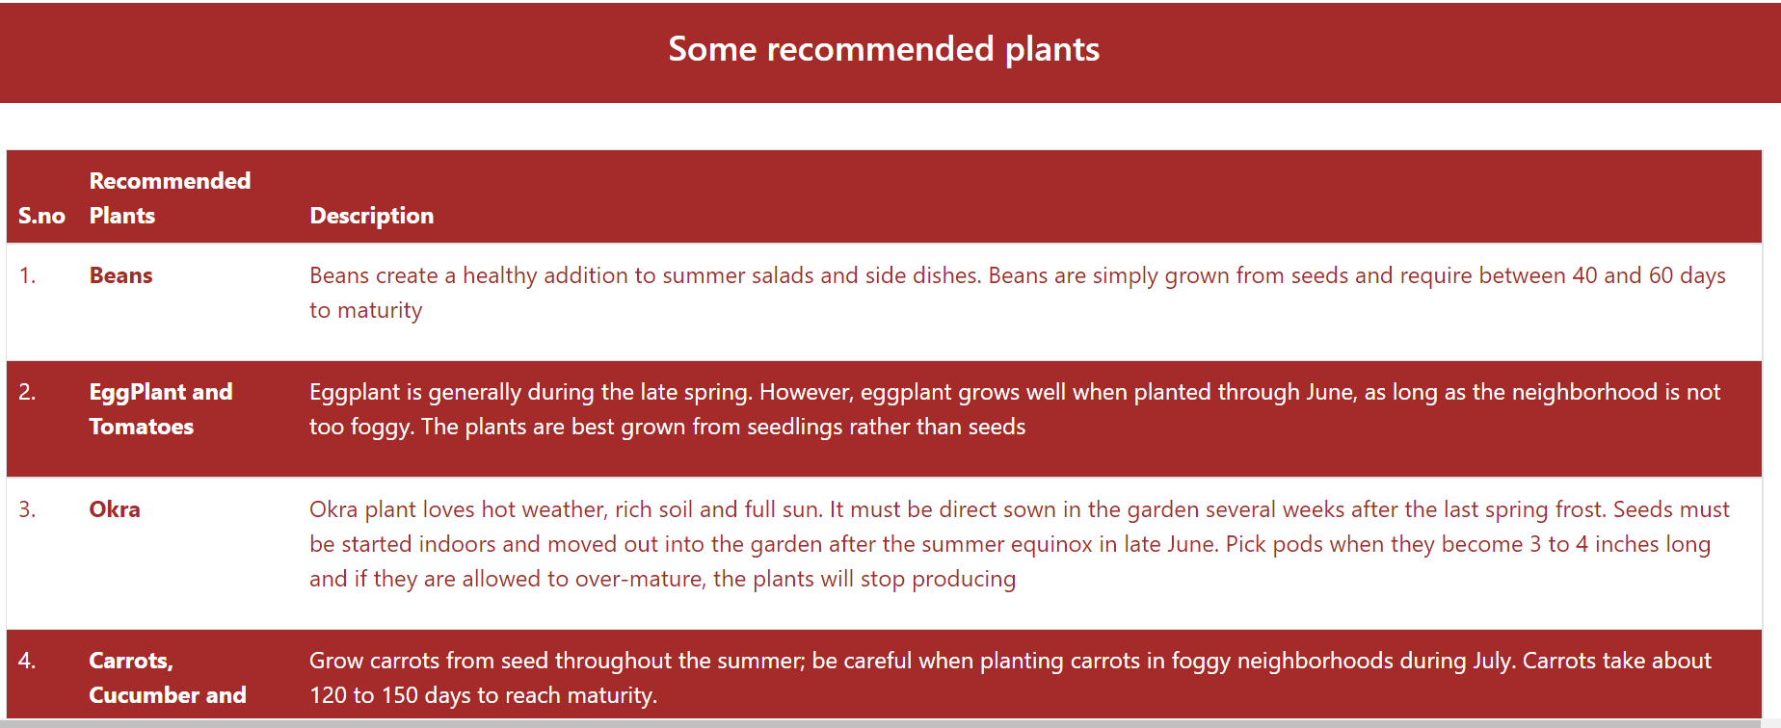

# CHAPTER 10

## ADVANTAGES & DISADVANTAGES

### ADVANTAGES

* + - Exploratory research offers a great amount of researcher discretion.
    - Exploratory research is the economical way in which the process can be conducted.
    - Exploratory research when done properly can lay a strong foundation for any study that is carried around the same issue in the future.
    - Analyzing the feasibility and viability of the research issue is another pro of exploratory research.

### DISADVANTAGES

* + - Exploratory research brings up tentative results and so is inconclusive.
    - Exploratory research is its qualitative data and subsequent analysis.
    - The small sample used for exploratory research increases the risk of the sample responses being non-representative of the target audience.
    - Data, when gathered through secondary resources, can supply obsolete information which may not generate any significant contribution to the understanding of an issue in the current scenario.

**CHAPTER 11**

## CONCLUSION

# This project demonstrated a web application that uses machine learning to analyze rainfall data for Flask, HTML, CSS, Python, and a few other technologies were used to create this project. The model predicts the handwritten digit using a CNN network. During testing, the model achieved a 98% recognition rate. The proposed project is scalable and can easily handle a huge number of users. Since it is a web application, it is compatible with any device that can run a browser. This project is extremely useful in real-world scenarios such as predicting the weather, cultivating suitable crops and increasing the production yield.

# CHAPTER 12

## FUTURE SCOPE

## The fundamental characteristic of rainfall as reported here whether by the day, month, year, or decades its indeterminate spatial and temporal variability.

## If local communities can learn from the lessons of indigenous cultures and adapt to dealing with the range of natural variability's reported here, they should be well-prepared to deal with the uncertainties of climate behaviours in the future.

## Clearly the causal relationship between the variability of local climate and regional-scale forcing in the global atmosphere needs to be better understood if climate science is to be relevant to the emerging societal needs of the India.

## This implies better on-the-ground observations, both in support of reﬁned modelling and as an immediate and practical tool for local water managers.

## APPENDIX

### SOURCE CODE:

**MODEL CREATION:**

# Libraries required

import pandas as pd

import numpy as np

import seaborn as sns

import matplotlib.pyplot as plt

from sklearn import preprocessing

from sklearn import model_selection

from sklearn import metrics

from sklearn import linear_model

from sklearn import ensemble

from sklearn import tree

from sklearn import svm

import xgboost

data = pd.read_csv("/content/sample_data/Dataset - Dataset.csv")

data = pd.read_csv("/content/sample_data/Dataset - Dataset.csv")

data.head()

import missingno as msno

msno.matrix(data, color= (0.55, 0.255, 0.225), fontsize=16)

#Loading the names of categorical columns

cat_names=data_cat.columns

# intializing the simple imputer for missing categorical values

import numpy as np

from sklearn.impute import SimpleImputer

imp_mode= SimpleImputer(missing_values=np.nan, strategy='most_frequent')

# fitting and transforming the missing data

data_cat=imp_mode.fit_transform(data_cat)

# converting array to dataframe

data_cat= pd.DataFrame(data_cat, columns=cat_names)

# concatinating the categorical and numeric

data = pd.concat([data, data_cat], axis=1)

from sklearn.preprocessing import StandardScaler

x=data.drop(columns=['Date','Location','RainTomorrow','RainToday', 'WindGustDir', 'WindDir9am', 'WindDir3pm'] , axis=1)

y=data['RainTomorrow']

def clean_dataset(df):

assert isinstance(df, pd.DataFrame), "df needs to be a pd.DataFrame"

df.dropna(inplace=True)

indices_to_keep = ~df.isin([np.nan, np.inf, -np.inf]).any(1)

return df[indices_to_keep].astype(np.float64)

x=clean_dataset(x)

names= x.columns # Loading the names of the x_features

sc=StandardScaler()

# fitting an transforming the data into standard

x=sc.fit_transform(x)

x= pd.DataFrame(x, columns=names)

from sklearn import model_selection

x_train,x_test,y_train,y_test=model_selection.train_test_split(x,y, test_size=0.2, random_state =0)

#Models intilization of the models

import sklearn

XGBoost = xgboost.XGBRFClassifier()

Rand_forest = sklearn.ensemble. RandomForestClassifier()

svm=sklearn.svm.SVC()

Dtree=sklearn.tree. DecisionTreeClassifier()

GBM = sklearn.ensemble. GradientBoostingClassifier()

log=sklearn.linear_model.LogisticRegression()

# fitting the model

XGBoost.fit(x_train,y_train)

Rand_forest.fit(x_train, y_train)

svm.fit(x_train,y_train)

Dtree.fit(x_train,y_train)

GBM.fit(x_train,y_train)

log.fit(x_train,y_train)

LogisticRegression()

#predicting the train values

p1=XGBoost.predict(x_train)

P2=Rand_forest.predict(x_train)

p3=svm.predict(x_train)

p4 = Dtree.predict(x_train)

p5=GBM.predict(x_train)

p6= log.predict(x_train)

**FLASK APP:**

from flask import Flask,redirect,url_for,request,render_template

from rainfall_prediction import prediction

app = Flask(__name__)

@app.route('/')

def hello_world():

return render_template('index.html')

@app.route('/auto-fill',methods=["POST"])

def auto_fill():

form_data = request.form

result = prediction(form_data['Location'])

if result==1:

return redirect(url_for('rainfall',location=form_data['Location']))

else:

return redirect(url_for('no_rainfall',location=form_data['Location']))

@app.route('/rain/<location>',methods=["GET"])

def rainfall(location):

return render_template('rainfall.html',location=location)

@app.route('/no-rain/<location>',methods=["GET"])

def no_rainfall(location):

return render_template('no_rainfall.html',location=location)

if __name__=="__main__":

app.run(debug=True)

**INDEX PAGE(HTML):**

<!DOCTYPE html>

<html lang="en">

<head>

<meta charset="UTF-8">

<meta http-equiv="X-UA-Compatible" content="IE=edge">

<meta name="viewport" content="width=device-width, initial-scale=1.0">

<title>PRIEE - Predictor</title>

<!-- CSS only -->

<link href="https://cdn.jsdelivr.net/npm/bootstrap@5.2.2/dist/css/bootstrap.min.css" rel="stylesheet">

<link rel="stylesheet" href="{{ url_for('static',filename='css/styles.css') }}"/>

<!-- JavaScript Bundle with Popper -->

<script src="https://cdn.jsdelivr.net/npm/bootstrap@5.2.2/dist/js/bootstrap.bundle.min.js" integrity="sha384-OERcA2EqjJCMA+/3y+gxIOqMEjwtxJY7qPCqsdltbNJuaOe923+mo//f6V8Qbsw3" ></script>

</head>

<body>

<!-- Navbar Section -->

<section class="Navbar">

<div class="navbar-container">

<ul class="navbar-list">

<li class="navbar-link-item"><a href="#">Home</a></li>

<li class="navbar-link-item"><a href="#About">About</a></li>

<li class="navbar-link-item"><a href="#prediction">Predict Rainfall</a></li>

<li class="navbar-link-item"><a href="#visualisation">Visualisation</a></li>

<li class="navbar-link-item"><a href="#footer">Contact Us</a></li>

</ul>

</div>

</section>

<section id="About">

<div class="title-container">

<h4>About Us</h4>

</div>

<div class="about-container">

<p>Lorem ipsum dolor sit amet consectetur, adipisicing elit. Ratione tempore recusandae, nulla, expedita consequuntur aspernatur placeat debitis dolores esse ipsa ipsam illum et perferendis, asperiores minima similique corrupti minus ipsum cumque? Aut voluptatibus facilis deleniti saepe labore, pariatur hic veritatis dolores vitae iste eum exercitationem nesciunt voluptas illo quia laborum?</p>

</div>

</section>

<!-- Prediction Section -->

<section id="prediction">

<div class="title-container">

<h4>Predict Rainfall</h4>

</div>

<div class="form-container">

<form action="{{url_for('auto_fill')}}" method="post">

<!-- <label for="Location">Location : </label> -->

<select id="location" name="Location">

<option value="location">Select Location</option>

<option value="Canberra">canberra</option>

<option value="Sydney">Sydney</option>

<option value="Melbourne">Melbourne</option>

<option value="Albury">Albury</option>

<option value="Bendigo">Bendigo</option>

<option value="Ballarat">Ballarat</option>

<option value="MountGinini">MountGinini</option>

<option value="Wollongong">Wollongong</option>

<option value="Penrith">Penrith </option>

<option value="Tuggeranong">Tuggeranong</option>

<option value="Newcastle">Newcastle</option>

<option value="CoffsHarbour">CoffsHarbour</option>

<option value="Watsonia">Watsonia </option>

<option value="Portland">Portland</option>

<option value="Mildura">Mildura</option>

<option value="Cobar">Cobar</option>

<option value="MelbourneAirport">MelbourneAirport</option>

<option value="Sale">Sale</option>

<option value="Moree">Moree</option>

<option value="Richmond ">Richmond </option>

<option value="BadgerysCreek">BadgerysCreek</option>

<option value="Williamtown">Williamtown</option>

<option value="WaggaWagga">WaggaWagga</option>

<option value="SydneyAirport">SydneyAirport</option>

<option value="NorfolkIsland">NorfolkIsland</option>

<option value="NorahHead">NorahHead</option>

<option value="Brisbane">Brisbane</option>

<option value="Nhil">Nhil</option>

</select>

<input type="submit" value="Get Prediction"/>

</form>

</div>

</section>

<!-- Visualisation Section -->

<section id="visualisation">

<div class="title-container">

<h4>Visualisation of Rainfall in India</h4>

</div>

<div class="visualisation-image-container">

<img src="./images/">

</div>

</section>

<!-- Footer -->

<section id="footer">

<div class="footer-container">

<ul class="social-media-list">

<li class="social-link-item"><a href="#"><svg xmlns="http://www.w3.org/2000/svg" width="20" height="20" fill="white" class="bi bi-facebook" viewBox="0 0 16 16">

<path d="M16 8.049c0-4.446-3.582-8.05-8-8.05C3.58 0-.002 3.603-.002 8.05c0 4.017 2.926 7.347 6.75 7.951v-5.625h-2.03V8.05H6.75V6.275c0-2.017 1.195-3.131 3.022-3.131.876 0 1.791.157 1.791.157v1.98h-1.009c-.993 0-1.303.621-1.303 1.258v1.51h2.218l-.354 2.326H9.25V16c3.824-.604 6.75-3.934 6.75-7.951z"/>

</svg></a></li>

<li class="social-link-item"><a href="#"><svg xmlns="http://www.w3.org/2000/svg" width="20" height="20" fill="white" class="bi bi-instagram" viewBox="0 0 16 16">

</svg></a></li>

<li class="social-link-item"><a href="#"><svg xmlns="http://www.w3.org/2000/svg" width="20" height="20" fill="white" class="bi bi-youtube" viewBox="0 0 16 16">

</svg></a></li>

<li class="social-link-item"><a href="#"><svg xmlns="http://www.w3.org/2000/svg" width="20" height="20" fill="white" class="bi bi-linkedin" viewBox="0 0 16 16">

</svg></a></li>

</ul>

<ul class="footer-list">

<li class="footer-link-item">IBM PRIEE Rainfall Predictor &copy; 2022 IBM Corportation</li>

</ul>

</div>

</section>

</body>

</html>

**RAINFALL(HTML):**

<!DOCTYPE html>

<html lang="en">

<head>

<meta charset="UTF-8">

<meta http-equiv="X-UA-Compatible" content="IE=edge">

<meta name="viewport" content="width=device-width, initial-scale=1.0">

<title>No Rainfall</title>

<link href="https://cdn.jsdelivr.net/npm/bootstrap@5.2.2/dist/css/bootstrap.min.css" rel="stylesheet">

<link rel="stylesheet" href="{{ url_for('static',filename='css/result_styles.css') }}"/>

<!-- <link rel="stylesheet" href="../static/css/result_styles.css"/> -->

<script src="https://cdn.jsdelivr.net/npm/bootstrap@5.2.2/dist/js/bootstrap.bundle.min.js" integrity="sha384-OERcA2EqjJCMA+/3y+gxIOqMEjwtxJY7qPCqsdltbNJuaOe923+mo//f6V8Qbsw3" ></script>

</head>

<body>

<!-- <p> Hurray!!! There won't be any rainfall tomorrow in {{location}}</p> -->

<section id="container">

<div class="title-container">

<svg xmlns="http://www.w3.org/2000/svg" width="30" height="30" fill="currentColor" class="bi bi-cloud-lightning-rain-fill" viewBox="0 0 16 16">

</svg>

<h4>Oops!! We could have a rainfall tomorrow in {{location}}</h4>

</div>

<div class="recommended-title-container">

<h4>Some Recommended Practice Are : </h4>

</div>

<div class="recommended-practices">

<ul class="list-container">

<li class="list-item"><p>Make the roof of livestock sheds leak-proof and clean.Livestock owners must cut some of the young grass of rainy season and before feeding, dry it up in sunshine. It will reduce water in grass and it will turn into a good feed.</p></li>

<li class="list-item"><p>Deworming must be done in the beginning of the rainy season and throughout the season because worms multiply at a greater rate during this period.Farmers should spray their animals regularly for removal of ectoparasites and cut all bushes near their sheds.</p></li>

<li class="list-item"><p>Farm should be disinfected using a disinfectant regularly.It must be made sure that feeds are stored in a dry place.</p></li>

<li class="list-item"><p>Make sure to install a fence around any open water sources on the farm to prevent people from tripping over them during the wet season. During the rainy season, it would be difficult for you and your employees to locate lakes or wells, and muddy banks could result in someone slipping or, worst yet, drowning. You could preserve not just yourself but also small farm animals by erecting barriers around open water regions.</p></li>

<li class="list-item"><p>Keep your crops out of the rain, especially those that are ready for harvest, as letting them sit on soggy soil might have unfavorable impacts. Produce from the farm may have moisture that encourages microbial growth, which results in fungus and mould. The consumption of these tainted goods can be harmful to both human and animal health.</p></li>

</ul>

</div>

<div class="plants-recommended-container">

<div class="table-title-container">

<h4>Some recommended plants</h4>

</div>

<div class="table-container">

<table class="table">

<thead>

<th>S.no</th>

<th>Recommended Plants</th>

<th>Description</th>

</thead>

<tbody>

<tr>

<td>1.</td>

<th>Rice</th>

<td><p>India is one of the biggest producers of white and brown rice in the world. It supplies more than half of the Indian population and up to one-third of India’s total cultivated land. Although it is grown in most Indian states, West Bengal, Punjab, and Uttar Pradesh are the top three states for rice production. Since India produces the most rice, it is recommended to grow rice during the monsoon season. It needs an average temperature of 25 to 26 degrees Celsius and at least 100 centimeters of precipitation. Of all the cities, only Punjab and Haryana produce expensive rice for export.</p></td>

</tr>

<tr>

<td>2.</td>

<th>Cotton</th>

<td><p>India also referred to as “White Gold,” ranks third in the world for cotton production. Cotton, a tropical and subtropical crop is another Kharif crop. Cotton is regarded as a crop for making fiber. Oil from its seed is used in cooking. Long, medium and short-staple varieties of Kharif crops include cotton. Cotton needs between 21 and 30 degrees Celsius and at least 50 to 100 cm of rain each year to flourish. Gujarat, Maharashtra, Andhra Pradesh, Haryana, Rajasthan, Karnataka, Tamil Nadu, and Orissa are the states that produce the most cotton overall. Gujarat has the highest rating overall, according to the prior study. About 75% of the rainfall needed for cotton cultivation is delivered during the monsoon.</p></td>

</tr>

<tr>

<td>3.</td>

<th>Sugarcane</th>

<td><p>An ancient crop, sugarcane is grown in tropical and subtropical regions. Sugarcane is used to make over 79 percent of all sugar. Falernum, molasses, rum, ethanol, and other products generated from sugarcane are among the few others. Only during the monsoon season is sugarcane grown. It also needs agroclimatic zones with hot, humid weather. The regions for developing sugarcane are the North Western, North Central, North Eastern, Peninsular Zone, and coastal zones. The ideal temperature for stem cuttings is between 32 and 38 degrees Celsius, whereas 14 to 16 degrees Celsius are required for ripening. </p></td>

</tr>

<tr>

<td>4.</td>

<th>Tea</th>

<td><p>The nature of a tea plantation is quite dynamic, and it can withstand both heavy snowfall and frost. As a result, it may typically grow in a variety of conditions across the nation, from subtropical to tropical.</p></td>

</tr>

<tr>

<td>5.</td>

<th>Pulses</th>

<td><p>The sowing of Kharif crops is slowed down by late monsoons, and production may be damaged and delayed as a result. India receives 70% of its rainfall from the monsoon, which is also essential to the country’s agriculture production and economy.</p></td>

</tr>

</tbody>

</table>

</div>

</div>

</section>

</body>

</html>

**NO RAINFALL (HTML):**

<!DOCTYPE html>

<html lang="en">

<head>

<meta charset="UTF-8">

<meta http-equiv="X-UA-Compatible" content="IE=edge">

<meta name="viewport" content="width=device-width, initial-scale=1.0">

<title>No Rainfall</title>

<link href="https://cdn.jsdelivr.net/npm/bootstrap@5.2.2/dist/css/bootstrap.min.css" rel="stylesheet">

<link rel="stylesheet" href="{{ url_for('static',filename='css/result_styles.css') }}"/>

<!-- <link rel="stylesheet" href="../static/css/result_styles.css"/> -->

<script src="https://cdn.jsdelivr.net/npm/bootstrap@5.2.2/dist/js/bootstrap.bundle.min.js" integrity="sha384-OERcA2EqjJCMA+/3y+gxIOqMEjwtxJY7qPCqsdltbNJuaOe923+mo//f6V8Qbsw3" ></script>

</head>

<body>

<!-- <p> Hurray!!! There won't be any rainfall tomorrow in {{location}}</p> -->

<section id="container">

<div class="title-container">

<svg xmlns="http://www.w3.org/2000/svg" width="30" height="30" fill="white" class="bi bi-cloud-sun-fill" viewBox="0 0 16 16">

</svg><h4> Hurray!! We won't have rain tomorrow in {{location}}</h4>

</div>

<div class="recommended-title-container">

<h4>Some Recommended Practice Are : </h4>

</div>

<div class="recommended-practices">

<ul class="list-container">

<li class="list-item"><p>Sandy soils can be problematic because of excessive drainage of water and nutrients as well as the presence of nematodes. This, in turn, can lead to the stress of the crops and effect in smaller yields. Summer is a good season for vegetable gardening</p></li>

<li class="list-item"><p>Veggies that like to grow under full sunshine enjoy long days and warm climate; thrive well in harsh Indian summer. The good thing about summer vegetable plants is that the same ones can be continued in monsoon season as well. Plant this in high spring, after the threat of frost is past. These tender vegetables require warm weather (65 to 90°F) to grow and are killed by frost.</p></li>

<li class="list-item"><p>Soil testing should be on your to-do list right from the get-go because your soil and it's required will directly influence the growth of vegetable crops. Examining the phosphorus, potassium, and fertilization levels will give you insight into how to handle vegetable crops. It will also let you know when proper soil conditions are forming, for example, the optimal density and right amount of nutrients, so you are prepared to start planting. The function of nutrients in vegetables is complex and includes processes like root, shoot, leaf and fruit development, production of proteins, hormones and chlorophyll, photosynthesis, etc. Soil is the major source of these nutrients to plants and soil fertility (or nutrient content) can, therefore, have a profound impact on crop production. The absence of any one of nutrients has the potential to decrease crop yield by negatively affecting the growth factor.</p></li>

</ul>

</div>

<div class="plants-recommended-container">

<div class="table-title-container">

<h4>Some recommended plants</h4>

</div>

<div class="table-container">

<table class="table">

<thead>

<th>S.no</th>

<th>Recommended Plants</th>

<th>Description</th>

</thead>

<tbody>

<tr>

<td>1.</td>

<th>Beans</th>

<td><p>Beans create a healthy addition to summer salads and side dishes. Beans are simply grown from seeds and require between 40 and 60 days to maturity</p></td>

</tr>

<tr>

<td>2.</td>

<th>EggPlant and Tomatoes</th>

<td><p>Eggplant is generally during the late spring. However, eggplant grows well when planted through June, as long as the neighborhood is not too foggy. The plants are best grown from seedlings rather than seeds</p></td>

</tr>

<tr>

<td>3.</td>

<th>Okra</th>

<td><p>Okra plant loves hot weather, rich soil and full sun. It must be direct sown in the garden several weeks after the last spring frost. Seeds must be started indoors and moved out into the garden after the summer equinox in late June. Pick pods when they become 3 to 4 inches long and if they are allowed to over-mature, the plants will stop producing</p></td>

</tr>

<tr>

<td>4.</td>

<th>Carrots, Cucumber and Corn</th>

<td><p>Grow carrots from seed throughout the summer; be careful when planting carrots in foggy neighborhoods during July. Carrots take about 120 to 150 days to reach maturity.</p></td>

</tr>

<tr>

<td>5.</td>

<th>Peppers, Pumpkins and Squashes</th>

<td><p>Peppers add flavor to the summer vegetable garden. Most peppers are planted during the spring, planting can continue up through the June to ensure fresh peppers all summer long. Start summer squashes in the garden as early as May, but also planted throughout June and July. Obtain a jump-start on the fall by planting pumpkins and squashes in June</p></td>

</tr>

<tr>

<td>6.</td>

<th>Sweet Potatoes</th>

<td><p>Sweet potatoes differ from regular potatoes in that they like warm weather. These plants are cold-sensitive and do best when planted about a month after the last frost date</p></td>

</tr>

<tr>

<td>7.</td>

<th>Summer Squash and Zucchini</th>

<td><p>Squash does not transplant well so it is best to direct sow it in the garden after the last frost date or choose plants in biodegradable peat pots that can be planted along with the squash. Summer squash requires nutrient-rich, well-drained soil.</p></td>

</tr>

<tr>

<td>8.</td>

<th>Chilli</th>

<td><p>Chilli as a spice is popular in India. The most pungent varieties of chilies can be grown in the hot summer season. The non-pungent type varieties are delicate and susceptible to diseases. The seedlings are transplanted. Heat is key for growing chilies and requires a hot, sun-drenched space, preferably up against a heat-reflecting wall that helps to collect extra rays of warmth. Those in cooler climates often make the best chilies in hoop houses or any other insulated environment. Though, do not let its infatuation with heat throw the basic demands of the plant. Even the toughest dudes require food and water to survive and the chili is no exception. Chilli is known to be an aphrodisiac but arrives there you have to be persistent.</p></td>

</tr>

<tr>

<td>9.</td>

<th>Capsicum</th>

<td><p>Capsicum is a crop that is best planted once the soil temperature has balanced out at a balmy 20 °C and above. Much like its cousins, it is a heat-loving variety that will choose a sunny place in the patch with a little airflow to help avoid any fungal disease.</p></td>

</tr>

</tbody>

</table>

</div>

</div>

</section>

</body>

</html>

 **GITHUB**

https://github.com/IBM-EPBL/IBM-Project-13458-1659518919

### PROJECT DEMO

https://drive.google.com/file/d/10UGckhpvl5N8EQvwZ1WtMt2j-SVr9JgE/view?usp=sharing